

Capstone Project Phase A

**A Tool for Analyzing fNIRS Hyperscanning Using Graph Measures**

25-1-D-1

Authors: Sara Saleh, Yonatan Sherer  
Supervisor: Dr. Anat Dahan

Table of Contents

**Abstract3**

**Introduction4**

**Theoretical Background5**

Hyperscanning5

fNIRS6

Graph Theory7

Data Preprocessing7

Connectivity Analysis7

Graph Construction7

Graph Measures8

**Problem Statement9**

**The Existing Solutions9**

Advancements with Graph Theory10

Limitations of Current Methods and Opportunities for Innovation11

**Literature Review12**

“Applications of Graph Theory to the Analysis of fNIRS Data in Hyperscanning Paradigms”12

Data Transformation into Graphs13

Graph Measures Used13

Comparison Using Graph Measures14

“Hyperscanning fNIRS Data Analysis Using Multiregression Dynamic Models”16

“Analyzing teacher–student interactions through graph theory applied to hyperscanning fNIRS data”19

Experiment Conditions20

Graph Measures20

**The Solution’s Workflow23**

**Flowchart26**

**References28**

Abstract  
Recent studies in the brain scanning field, particularly fNIRS hyperscanning, have demonstrated their need to analyze scanned data efficiently. Researchers try to figure out the role of certain brain regions and how they relate to specific daily tasks of their participants. Current tools are not yet capable of verifying the accuracy of their hypotheses, which presents a major obstacle to the continuation of their journey to final conclusions. To solve this problem, this project aims to create an interactive tool which supports input of fNIRS hyperscanning data, tailored to neuroscientists’ field terms. Our suggested method builds a framework in which the information produced by fNIRS hyperscanning recordings may be analyzed using graph measures.

The system features an API that lets a neuroscientist interact with an environment that provides more insights about its brain scanning results.  
Hence, graph measures such as modularity then displayed, promise to enhance the scientists understanding of certain active brain regions at different daily tasks.  
The analysis of these metrics may provide further insights into the neurobiological underpinnings of interaction, such as in educational contexts.[1]

Introduction

In recent years, the exploration of brain activity during social interactions has gained significant attention, particularly through the use of hyperscanning techniques. Functional Near-Infrared Spectroscopy (fNIRS), a non-invasive imaging tool, has emerged as a powerful method for capturing real-time neural dynamics in multiple participants engaged in shared tasks. This advancement has opened doors to new possibilities in studying inter-brain synchronization and the complex neural mechanisms underpinning collaboration, communication, and learning. However, analyzing hyperscanning data poses unique challenges. Traditional tools often fail to capture the intricate network structures of brain connectivity, limiting researchers to basic correlations between specific brain regions. To address this gap, our project introduces an innovative tool that leverages graph theory to transform fNIRS hyperscanning data into meaningful insights. By representing brain regions as nodes and their interactions as edges, this tool enables the application of advanced graph measures to quantify connectivity patterns and identify neural networks' functional properties. Our book presents the development, methodology, and applications of this tool, designed to empower neuroscientists with an interactive framework for analyzing brain activity. With features like data preprocessing, graph construction, and connectivity visualization, this solution bridges the gap between raw data and actionable insights. By integrating cutting-edge approaches with user-friendly interfaces, we aim to advance the study of neural dynamics and foster deeper understanding in educational, collaborative, and social contexts.

Theoretical Background

**Hyperscanning** is a method for simultaneously measuring brain activity in two or more individuals during shared tasks or social interactions. The technique is used to study brain synchronization and communication in various activities, including:

1. Social Interactions

* Collaborative Problem Solving: Studying brain activity in pairs as they work together to solve puzzles or complex tasks. For example, examining how neural synchronization correlates with successful teamwork.[5]
* Parent-Child Interactions: Observing neural synchronization during activities like storytelling, playing games, or emotional communication.[6]

2. Communication and Language

* Conversation Dynamics: Exploring brain synchronization during natural conversations to understand turn-taking, empathy, or shared understanding.[7]
* Teacher-Student Interactions: Monitoring how teaching effectiveness and learning engagement relate to brain coupling during educational tasks.[8]
* Nonverbal Communication: Analyzing how gestures, facial expressions, or body language affect neural synchrony during interactions.[9]

3. Music and Performance

* Musical Duets: Measuring synchronization between musicians as they perform together, examining how coordination and emotional connection influence their neural activity.[10]
* Dance and Movement: Studying brain coupling during synchronized dance or physical activities requiring coordination.[11]

4. Sports and Physical Activities

* Team Sports: Recording neural activity from team members to understand coordination, strategy, and shared attention during gameplay.[12]

5. Cognitive Load and Teaching

* Mentoring Scenarios: Observing how brain synchrony changes as mentors guide learners through complex tasks.[13]
* Simultaneous Learning Tasks: Studying dyads as they acquire new skills together and share cognitive load.[14]

**Functional Near-Infrared Spectroscopy (fNIRS)** is a non-invasive imaging technique that measures brain activity by detecting changes in blood oxygenation and volume. It utilizes near-infrared light (700–900 nm) to penetrate the scalp and skull, allowing for the monitoring of hemodynamic responses associated with neural activity. This method is particularly effective for assessing cortical functions and is valued for its portability, safety, and cost-effectiveness.

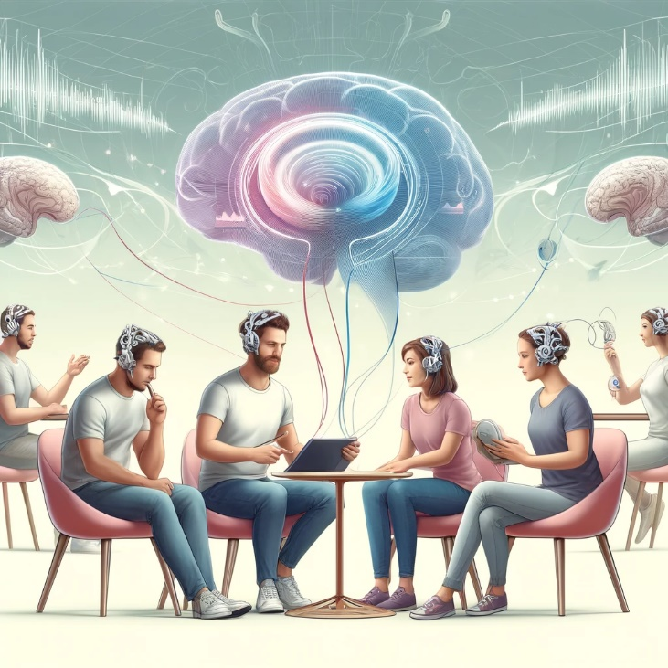

**Graph theory** is a branch of mathematics that studies the properties and relationships of graphs, which are mathematical structures used to model pairwise relationships between objects. A graph consists of nodes (vertices) and edges (connections between nodes), which can represent entities and their interactions in various contexts.

In the context of fNIRS hyperscanning, graph theory is a powerful tool to analyze brain activity and inter-brain synchronization. Hyperscanning involves simultaneously recording brain activity from multiple individuals engaged in a shared task or interaction. The data collected by fNIRS includes time-series measurements of oxygenated (HbO) and deoxygenated (HbR) hemoglobin concentrations across different brain regions.

To apply graph theory to fNIRS hyperscanning data, the following steps are typically involved:

1. Data Preprocessing: The raw fNIRS signals are preprocessed to remove noise, motion artifacts, and physiological signals unrelated to neural activity. Common methods include filtering, detrending, and signal normalization.[4]
2. Connectivity Analysis: Functional connectivity between brain regions is estimated based on the similarity or synchronization of the fNIRS signals. Common metrics include correlation (e.g., Pearson or partial correlation), coherence, or mutual information. For hyperscanning, inter-brain connectivity (between individuals) and intra-brain connectivity (within an individual) are both considered.[2]
3. Graph Construction: Once connectivity metrics are computed, a graph is constructed:
   * Nodes: Represent brain regions or fNIRS channels.
   * Edges: Represent the strength of functional connectivity between nodes. Thresholding is often applied to retain only significant connections, creating a sparse graph.
4. **Graph Measures**: To analyze the structure and properties of the resulting graph, various graph measures are calculated. These quantitative metrics help describe functional organization and network dynamics. Examples include:
   * Degree (node connectivity): Number of edges connected to a node, indicating how central a brain region is.
   * Clustering Coefficient (local grouping): Measures the tendency of a node's neighbors to form connections, reflecting local connectivity.
   * Path Length (shortest connections): The shortest path between two nodes, used to assess network efficiency.
   * Global Efficiency (information flow): Reflects how efficiently information is integrated across the entire network.
   * Modularity (community detection): Indicates the presence of distinct communities or modules within the network.
   * Small-Worldness: Describes networks that balance high local clustering with short path lengths, characteristic of efficient brain networks.

By applying these graph measures, researchers can study how functional brain networks change during social interaction, collaboration, or other shared activities in hyperscanning studies. For instance, they can investigate whether inter-brain connectivity increases during cooperative tasks or how network efficiency evolves under different conditions. This graph-based analysis provides a systematic way to interpret complex fNIRS data and gain insights into the neural mechanisms underlying individual and shared cognitive processes.

Problem Statement  
Neuroscientists conducting experiments with multi-participant fNIRS devices aim to uncover new insights about brain regions responsible for specific activities. The workflow typically involves conducting an fNIRS experiment, recording the results, analyzing the data, and interpreting the findings. However, the current tools lack the ability to efficiently model and analyze the data in ways that provide clear and actionable insights. The challenge lies in effectively capturing and analyzing inter-brain synchronization during such cooperative or interactive tasks. This synchronization reflects the shared neural dynamics that facilitate smooth coordination and mutual understanding. Existing methods often struggle with the complexity of real-world, dynamic interactions, requiring new tools to precisely evaluate and interpret these neural mechanisms.

Our proposed solution addresses this gap by introducing a tool that transforms fNIRS recordings into a graph model, where nodes and edges represent specific neural connections and interactions.  
This graph-based representation allows for the calculation of relevant metrics, which are then visualized through charts and diagrams.   
These visualizations enable researchers to gain a deeper understanding of brain activity and advance their studies with greater accuracy and efficiency. By automating complex analyses and presenting results in an intuitive manner, this tool provides neuroscientists with a streamlined and effective way to explore their hypotheses and make data-driven conclusions.

The Existing Solutions for analyzing fNIRS data in hyperscanning paradigms utilize a range of methods tailored to different research needs. The current landscape of fNIRS hyperscanning research often relies on analyzing data from a single electrode in each participant's brain, representing a specific region of interest. These studies commonly use methods such as Wavelet Transform Coherence (WTC) and Pearson Correlation to measure the relationship between the signals from these electrodes. These approaches focus on the bivariate correlation between two signals, effectively providing insights into how two distinct brain areas—one from each participant—synchronize during shared tasks or interactions.  
While these methods are computationally straightforward and widely adopted, they are inherently limited by their scope.

By examining only a single pair of regions, such methods treat the brain as a collection of isolated points rather than as a cohesive, interconnected network. This simplification overlooks the complexity of intra-brain (within one individual) and inter-brain (between multiple individuals) connectivity, failing to capture the broader picture of neural dynamics. It becomes challenging to fully understand how regions of the brain work together as part of a larger system, both within a single participant and across participants.

Advancements with Graph Theory: Graph theory introduces a powerful framework to address these limitations by allowing researchers to conceptualize and analyze the brain as a network. Instead of reducing brain connectivity to a single pair of regions, graph-based methods enable **multivariate analysis** of intra- and inter-brain connectivity. In this approach, nodes represent multiple brain regions (or fNIRS channels), and edges reflect the functional connectivity or synchronization between these nodes. This network-based perspective provides a richer understanding of brain activity and its collaborative dynamics.

Using graph theory, researchers can calculate global and local network properties—such as modularity, clustering coefficient, path length, and global efficiency—that describe how information flows across the brain. This shift from bivariate to multivariate analysis offers significant advantages:

1. **Comprehensive Insights**: Researchers can evaluate how entire networks of brain regions, rather than isolated points, contribute to task performance or social interaction.
2. **Inter- and Intra-Brain Dynamics**: It becomes possible to explore the complex interplay between regions within the same brain and across multiple brains in real-time.
3. **Hypothesis Testing**: The richer dataset allows for testing advanced hypotheses, such as whether neural networks become more integrated or modular during cooperative tasks.

Limitations of Current Methods and Opportunities for Innovation:  
The reliance on traditional techniques such as WTC or Pearson Correlation is not without merit—they are robust, relatively noise-resistant, and effective for detecting pairwise synchrony. However, they lack the ability to uncover higher-order interactions and network-wide phenomena. By incorporating graph theory into fNIRS hyperscanning studies, researchers can overcome these constraints, enabling tools and systems to explore neural synchronization at a much deeper and more comprehensive level. This advancement aligns with the growing need for sophisticated analytical methods capable of interpreting the complexity of brain connectivity in dynamic and social settings.

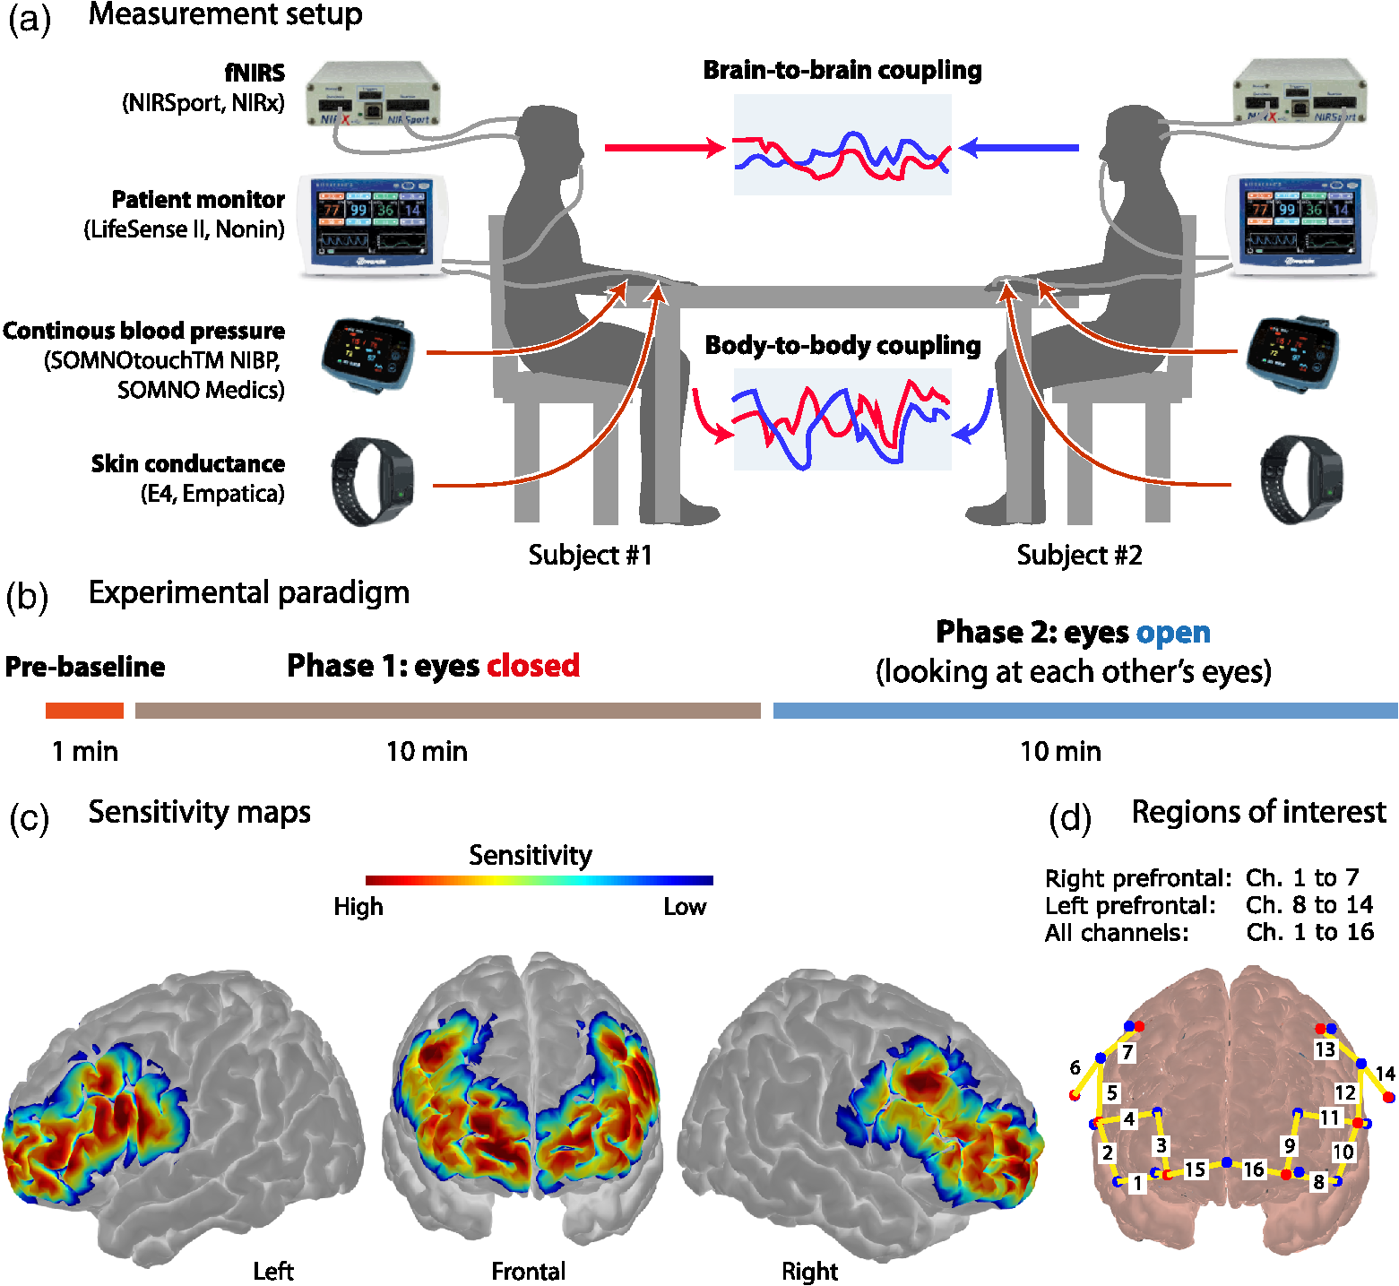

Literature Review

Functional Near-Infrared Spectroscopy (fNIRS) hyperscanning enables the simultaneous measurement of brain activity in multiple individuals during social interactions. Integrating graph theory into fNIRS data analysis facilitates the examination of complex neural connections and inter-brain synchronizations. In our search for applications of graph theory to the analysis of fNIRS hyperscanning, we found three studies detailing their methodologies and findings.

## 1. "Applications of Graph Theory to the Analysis of fNIRS Data in Hyperscanning Paradigms"[1]

This study explored the use of graph theory to evaluate global synchronization between brains during social interactions.   
The researchers introduced a bootstrap modularity test to determine coactivation in brain pairs (see definition below). They applied this method to fNIRS data collected from the prefrontal cortex and temporoparietal junction of five teacher-preschooler dyads engaged in an interaction task.  
The data were transformed into graphs by defining nodes as fNIRS channels, and edges as the statistical dependencies between them.  
The primary graph measure was modularity, which quantifies the degree to which a network can be partitioned into distinct communities.   
The bootstrap modularity test was applied to determine significant inter-brain synchronizations, revealing that the dyad's neural synchronization was influenced by the interplay between the teacher's language and number processing and the child's phonological processing.   
In this context, graph hub centrality measures revealed that the dyads' synchronization was significantly influenced by the interplay between the teacher's language and number processing and the child's phonological processing. This approach provided insights into the neurobiological foundations of interactions in educational settings.

Bootstrap modularity test evaluates the significance of modularity in a graph by comparing observed modularity to a distribution from resampled datasets. This ensures the identified community structure is meaningful and not random, providing reliable validation for network analyses like in fNIRS data.  
Data Transformation into Graphs: The fNIRS data were represented as networks where nodes corresponded to specific brain regions, and edges indicated functional connections based on synchronization metrics.

Graph Measures Used: Modularity and hub centrality measures were employed to evaluate the organization and significance of nodes within the network.

Comparison Using Graph Measures: The bootstrap modularity test evaluated the presence of coactivation between brain pairs, while hub centrality measures identified critical regions contributing to inter-brain synchronization.

## Participants: Five pairs of teacher-child which reported no cognitive disabilities participated in the experiment, as described in [Barreto et al. (2021)](https://www.frontiersin.org/journals/computational-neuroscience/articles/10.3389/fncom.2022.975743/full?utm_source=chatgpt.com#B4).

## Experiment: Experimental data was obtained using fNIRS. The fNIRS provides safe, comfortable, and realistic means for data collection in a natural condition. Safe levels of light (with wavelengths between 650 and 900 nm) were used to infer the oxygenation variation level of brain tissue in a non-invasive way. The light penetrates the biological tissue and reaches the cortex, allowing the analysis of oxyhemoglobin (O2Hb), deoxyhemoglobin (HHb), and total hemoglobin (tHb; tHb = O2Hb + HHb) from cerebral blood ([Delpy and Cope, 1997](https://www.frontiersin.org/journals/computational-neuroscience/articles/10.3389/fncom.2022.975743/full?utm_source=chatgpt.com#B15)).

The teacher-student data was collected in a hyperscanning paradigm, as described in [Brockington et al. (2018)](https://www.frontiersin.org/journals/computational-neuroscience/articles/10.3389/fncom.2022.975743/full?utm_source=chatgpt.com#B9), [Barreto et al. (2021)](https://www.frontiersin.org/journals/computational-neuroscience/articles/10.3389/fncom.2022.975743/full?utm_source=chatgpt.com#B4).

Briefly, the dyads interacted in a task which the teacher presents the mechanisms to sum two numbers (1 to 12) using matchsticks in a context of a space-race game with the child. They need to move two pawns (representing the child and the teacher) on a pathway board marked with numbers. At first, after throwing two six-sided dice, the player who got the highest sum started the game. They continued the race by walking the steps to the sum of the dice numbers until the finish line. 

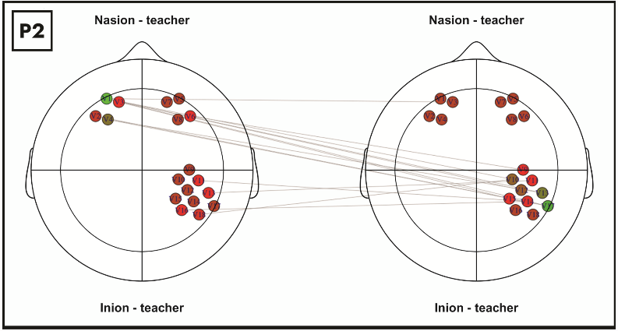 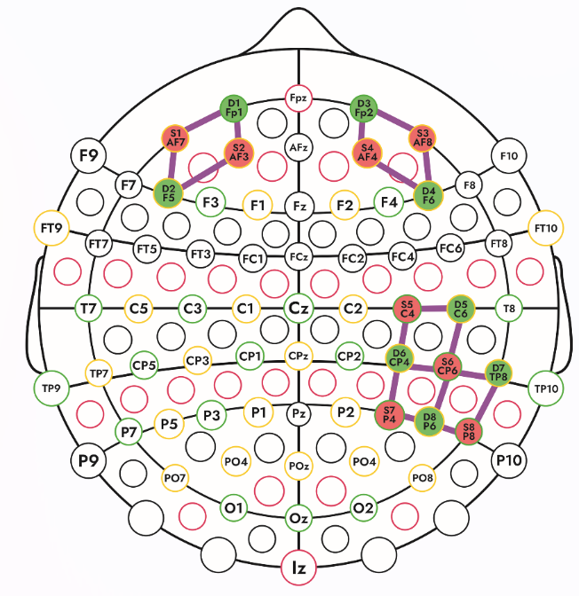  
 Image 1 Image 2

## 2. “Hyperscanning fNIRS Data Analysis Using Multiregression Dynamic Models”[2]

In this study, the authors proposed an approach to analyze fNIRS hyperscanning data by constructing dynamic graphical models. They utilized multiregression dynamic models to capture the temporal dependencies and interactions between different brain regions across multiple individuals. Nodes in the graph represented specific brain regions, while directed edges indicated the influence of one region on another over time.

The study employed several graph-theoretical measures to characterize the constructed dynamic networks. These included:

* Degree Centrality: Evaluated the number of direct connections a node has, indicating its immediate influence within the network.
* Betweenness Centrality: Measured the extent to which a node lies on the shortest paths between other nodes, reflecting its role as a mediator in the network.
* Clustering Coefficient: Evaluated the tendency of nodes to form tightly knit groups, providing insight into the local cohesiveness of the network.
* Global Efficiency: Quantified the overall efficiency of information transfer across the entire network, indicating how effectively information is exchanged.

The researchers applied these graph measures to compare the functional brain networks of individuals engaged in joint tasks versus those performing tasks independently. They observed that during collaborative activities, there was an increase in global efficiency and clustering coefficient, suggesting enhanced inter-brain connectivity and synchronized neural processing. Additionally, nodes corresponding to prefrontal regions exhibited higher degree and betweenness centrality during joint tasks, highlighting their pivotal role in coordinating social interactions.

## The data: This study dataset was first presented as a case study experiment (Balardin et al., [2017](https://pmc.ncbi.nlm.nih.gov/articles/PMC10413103/?utm_source=chatgpt.com#B3)) that considered two individuals who played in a violin duo. In the current study, the researchers have investigated the brain-to-brain coupling (and the direction) and explored which brain regions of a violinist are linked to the other.

The fNIRS signals acquired are demonstrated in [Figure 1](https://pmc.ncbi.nlm.nih.gov/articles/PMC10413103/?utm_source=chatgpt.com#F1) (for further experiment details, see Balardin et al., [2017](https://pmc.ncbi.nlm.nih.gov/articles/PMC10413103/?utm_source=chatgpt.com#B3)). Hemodynamic changes were obtained from the optical changes collected using the continuous wave functional near-infrared spectroscopy system.

Figure 1 - Violin duo experiment: inter-subjects' experiment icon **(A)**; fNIRS **(B)** and the observed brain region **(C)**.

## Experimental results: fNIRS enables simultaneous recording, making it possible to study the influence of brain-to-brain coupling through social interaction experiments. [Figure 5](https://pmc.ncbi.nlm.nih.gov/articles/PMC10413103/?utm_source=chatgpt.com#F5) shows the fNIRS data during the music duration (218 time points) from violinist A in the 23 channels.

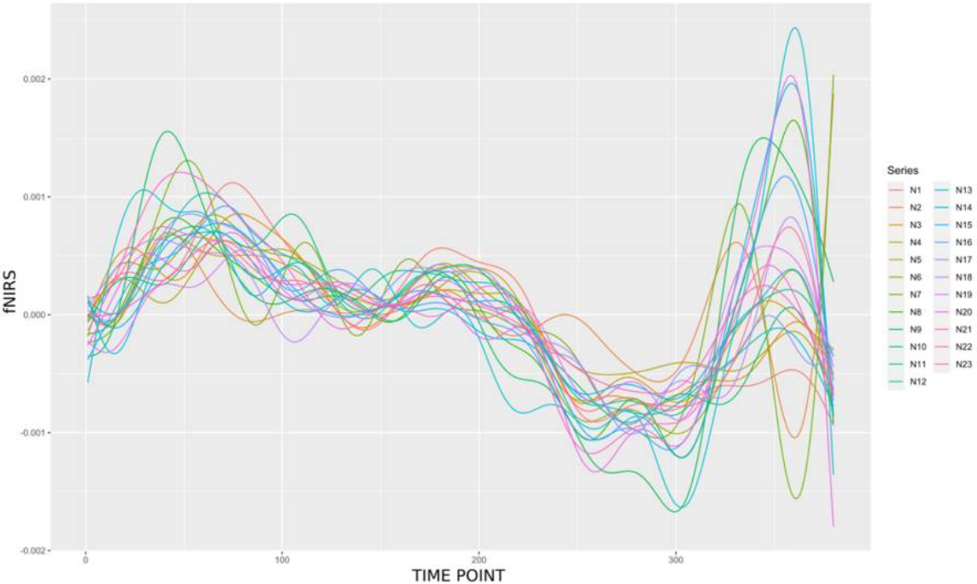

[Figure 5](https://pmc.ncbi.nlm.nih.gov/articles/PMC10413103/?utm_source=chatgpt.com#F5) - A butterfly plot illustrating the 23 oxyhemoglobin (HbO) signals from violinist A.

## 3. “Analyzing teacher–student interactions through graph theory applied to hyperscanning fNIRS data”[3]

This study utilized graph theory to represent interactions between teachers and students at the neural level. Through [hyperscanning](https://www.sciencedirect.com/topics/neuroscience/hyperscanning) with functional near-infrared spectroscopy (fNIRS), the researchers [collected data](https://www.sciencedirect.com/topics/computer-science/collected-data) from the [prefrontal cortex](https://www.sciencedirect.com/topics/psychology/prefrontal-cortex) and the [temporoparietal junction](https://www.sciencedirect.com/topics/psychology/temporoparietal-junction) of 24 dyads, composed of a teacher and a student. Each dyad used a board game to perform a programming logic class that consisted of three steps: independent activities (control), presentation of concepts, and interactive exercises. Graph theory provides results regarding the strength of teacher–student interaction and the main channels involved in these interactions. Graph modularity and bootstrap were combined to measure pair coactivation, thus establishing the strength of teacher–student interaction. Also, graph centrality detects the main brain channels involved during this interaction. In general, the teacher's most relevant nodes rely on the regions related to language and number processing, [spatial cognition](https://www.sciencedirect.com/topics/psychology/spatial-cognition), and attention. Also, the students' most relevant nodes rely on the regions related to task management.

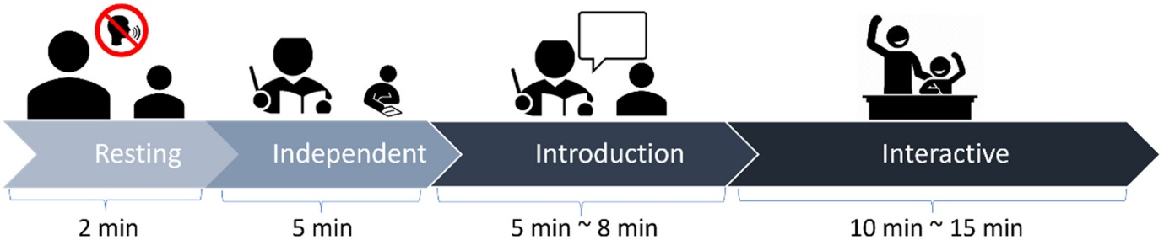

Fig. 1. Experimental design sequence - In the experiment, a board game was employed as an educational tool to teach computational thinking, utilizing pieces with directional, sequential, and logical elements within the context of a spaceship adventure, specifically focusing on structuring logical sequences.

## Data acquisition and preprocessing

Each teacher-student pair participated in a lesson recorded in a comfortable, well-lit room. fNIRS signals were collected under four conditions:

1. **Baseline:** Two minutes of rest without interaction.
2. **Independent Activity:** The teacher reviewed materials, while the student engaged in a drawing activity.
3. **Introduction:** A 5-minute session where the teacher explained lesson goals and materials.
4. **Interactive:** A 10-minute session involving challenges and guided solutions.

The data was processed to remove noise and interference using short-distance channels as regressors. After signal processing, the hemodynamic states were computed, and the data was organized and structured using the R programming language.

## Graph measures

The researchers’ main assumption was that student engagement can be indirectly evaluated through brain co-activation. This section presents how they computed the latter using graph theory using the same methodology as in [Oku et al. (2022)](https://www.sciencedirect.com/science/article/pii/S0079612323001115" \l "bb0170).

Initially, they constructed a graph [adjacency matrix](https://www.sciencedirect.com/topics/computer-science/adjacency-matrix), denoted as A, for each pair. First, the Spearman correlation between brain channels was calculated, resulting in a 32 × 32 matrix representing correlations for 16 teacher and 16 student channels. In order to evaluate brain co-activation, they applied additional transformations to this [correlation matrix](https://www.sciencedirect.com/topics/computer-science/correlation-matrix). Since they were interested in measuring brain co-activation, they set the values for intra-cerebral correlations to zero and for correlations below the threshold of corr = 0.25. Strong negative correlations were disregarded through this process since the focus is on co-activation. Finally, this process yielded an adjacency matrix and an [undirected graph](https://www.sciencedirect.com/topics/computer-science/directed-graphs) for each pair.

Through this graph, they obtained measures of pair co-activation. One such measure is the number of edges in A. Additionally, the correlations in A can also be seen as a measure of the strength of each edge. Hence, they also calculated the sum of the edge weights in A as an alternative measure of co-activation. The final way they evaluated co-activation was through modularity, often used to detect community structure in networks ([Newman, 2006](https://www.sciencedirect.com/science/article/pii/S0079612323001115" \l "bb0155)). Modularity measures how well a graph can be divided into two or more isolated groups of nodes (see [Newman and Girvan, 2004](https://www.sciencedirect.com/science/article/pii/S0079612323001115" \l "bb0160); [Oku et al., 2022](https://www.sciencedirect.com/science/article/pii/S0079612323001115#bb0170)). Hence, the higher the modularity of a graph, the lower the co-activation of the pair.

The above assessments of co-activation were complemented with measures of graph centrality. These measures identify the most important brain regions within the graph, indicating which nodes play a crucial role in co-activation.

## Results

The researchers implemented the above graph-based method and its measures to evaluate differences between levels of engagement between students and between class conditions.

## Levels of engagement between students

The measures of co-activation were calculated following the procedure in “Graph Measures” section. In this step, they used the full duration of the class (Introduction and Interactive lesson conditions) to build each pair's graph.

[Fig. 4](https://www.sciencedirect.com/science/article/pii/S0079612323001115" \l "f0025) illustrates the relation between student engagement and the proposed measures of co-activation. In summary, co-activation is a good proxy for student engagement. Edge count and weighted edge count directly represent co-activation and, indeed, these measures consistently increase with student engagement. On the other hand, modularity measures the [absence](https://www.sciencedirect.com/topics/neuroscience/epileptic-absence) of co-activation and decreases with student engagement.

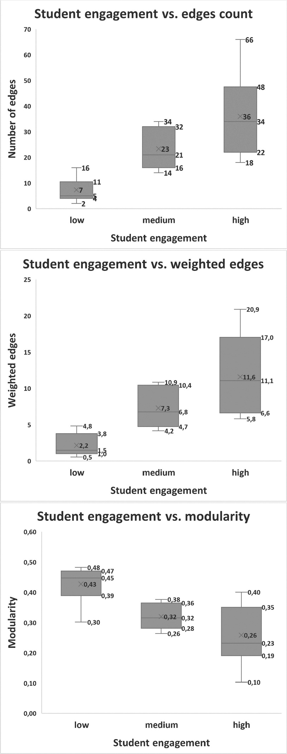Fig. 4. Boxplots for co-activation   
(upper: edge,  
medium: weighted edge,   
lower: modularity)  
in each group of student engagement during the entire class.

Since edge and weighted edge directly measure co-activation, this measure increases with student engagement. Modularity measures the opposite of co-activation and, hence, decreases with student engagement.  
In order to visualize the differences between classroom conditions, the researchers summarized the collection of pair graphs. Specifically, they built a single graph for each classroom condition, as illustrated in [Fig. 5](https://www.sciencedirect.com/science/article/pii/S0079612323001115" \l "f0030). The edges in these summary graphs are the 10% most frequent among all the dyads. Each vertex in the summary graph is [colored](https://www.sciencedirect.com/topics/social-sciences/coloureds) according to its respective [eigenvector centrality](https://www.sciencedirect.com/topics/computer-science/eigenvector-centrality), which is a measure of its importance with respect to the graphs' connectivity.

Fig. 5. Graph summaries generated from all dyads at each moment of the class. The graph associated with strictly introduction content displays edges linked to [PFC](https://www.sciencedirect.com/topics/psychology/prefrontal-cortex) regions in both teachers and students. In contrast, the graph resulting from interactive exercises indicates a larger portion of connections between [rTPJ](https://www.sciencedirect.com/topics/psychology/temporoparietal-junction" \o "Learn more about rTPJ from ScienceDirect's AI-generated Topic Pages) and PFC regions between students and teachers.

The Solution's workflow

Functional Near-Infrared Spectroscopy (fNIRS) hyperscanning helps understanding brain connectivity during social interactions, enabling researchers to explore the neural underpinnings of collaboration, communication, and other interpersonal dynamics. Advanced analytical tools are necessary for unlocking the full potential of fNIRS data, especially in hyperscanning applications, to derive meaningful insights.

Our system is designed as a comprehensive solution for fNIRS hyperscanning data analysis, utilizing graph measures to quantify and visualize brain connectivity. This tool streamlines the process from data preprocessing to the extraction of graph-based metrics, offering researchers an intuitive and robust framework to analyze inter-brain and intra-brain connectivity patterns. The workflow describes the methods to be used to ensure accessible to users with varying levels of technical expertise. The

The workflow incorporates cutting-edge methods, delivering high precision and reliability while being user-friendly for individuals with diverse technical backgrounds.

The following sections outline the key steps in the workflow, highlighting the seamless integration of data handling, graph construction, and connectivity analysis that empowers researchers to delve deeper into neural dynamics.

To develop a system or tool that transforms fNIRS recordings into a graph representation based on the methodologies described in the provided documents, the process would involve the following steps:

1. **Signal Correlation and Connectivity Analysis**:

This step involves determining the functional connectivity between different brain regions by analyzing the relationship between fNIRS signals. The process begins with the computation of correlation or coherence measures, such as Wavelet Transform Coherence (WTC) or Pearson’s correlation coefficient, to quantify the synchronization between signals. Functional connectivity reflects the degree of coupling between neural activity in different regions, offering insights into intra-brain and inter-brain dynamics. For hyperscanning scenarios, this includes both the analysis of connectivity within a single participant's brain and the synchronization between participants engaged in shared tasks. Preprocessing of fNIRS signals—such as filtering, detrending, and normalization—is a prerequisite to remove noise, motion artifacts, and physiological signals unrelated to neural activity, ensuring accuracy in the derived connectivity metrics. These connectivity analyses serve as the foundation for graph-based representations, enabling subsequent investigation of neural networks.

1. **Graph Construction**:
   * Define nodes as the ROIs in the brain and edges as the functional connections (based on significant correlations or coherence values).
   * Construct adjacency matrices, where each element represents the strength of the connection between two nodes. Apply thresholds to retain only meaningful connections​​.
2. **Graph Measures and Analysis**:
   * Calculate graph measures to evaluate network properties:
     + **Degree**: Number of connections for each node, reflecting centrality.
     + **Path Length**: Shortest path between nodes, measuring efficiency.
     + **Global Efficiency**: The ability of the graph to transmit information across distant nodes.
     + **Modularity**: The extent of division into subnetworks or clusters.
     + **Clustering Coefficient**: Tendency of nodes to form tightly connected groups​​.
3. **Perform comparison within the different conditions**:   
   The system provides the capability to compare various graph measures across conditions selected by the researcher, enabling a comprehensive understanding of neural dynamics under different experimental setups. For example, in conditions involving collaboration, modularity often decreases as neural networks become less segregated and more integrated, reflecting enhanced synchronization and interaction between brain regions. Conversely, the average path length within the graph may increase during collaborative tasks, indicating more distributed connectivity patterns that facilitate communication across larger portions of the network.
4. **Visualization**:
   * Use graph visualization tools to represent the network. Highlight properties such as highly connected nodes, distinct clusters, or differences in connectivity patterns under various experimental conditions​.
5. **Application and Validation**:
   * Test the system using experimental datasets (e.g., cooperative tasks, teacher-student interactions).
   * Validate the tool by comparing results with existing benchmarks or expected patterns from prior studies

**Flow Chart for fNIRS Hyperscanning Analysis Tool**

Demonstrations

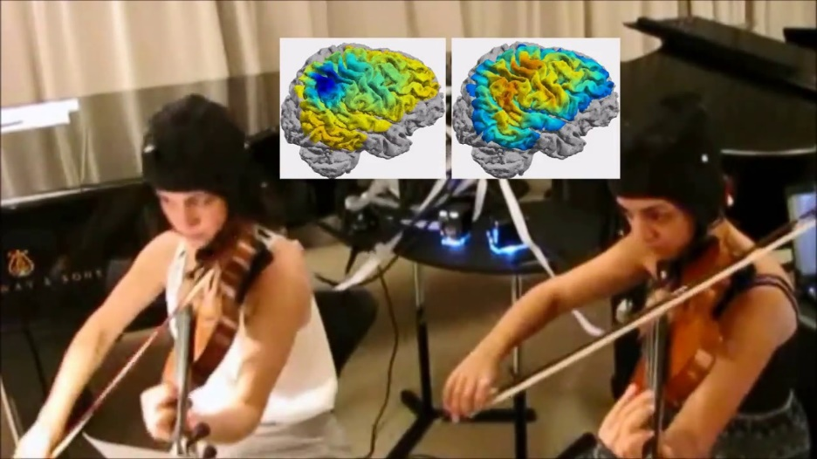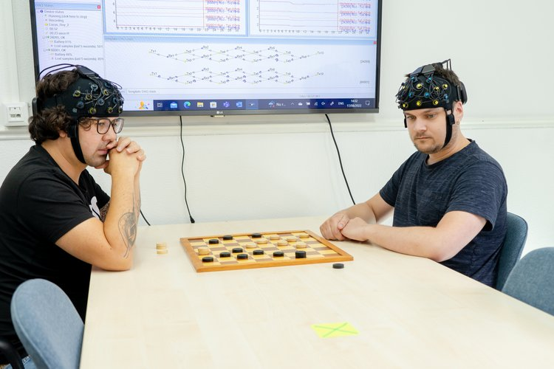

As demonstrated in “An fNIRS study to assess brain activity during a competitive checker game” and “fNIRS Responses in Professional Violinists While Playing Duets: Evidence for Distinct Leader and Follower Roles at the Brain Level”

References

[1] Oku, A. Y. A., Barreto, C., Bruneri, G., Brockington, G., Fujita, A., & Sato, J. R. (2022). Applications of graph theory to the analysis of fNIRS data in hyperscanning paradigms. *Frontiers in computational neuroscience*, *16*, 975743.

[2] do Nascimento, D. C., Santos da Silva, J. R., Ara, A., Sato, J. R., & Costa, L. (2023). Hyperscanning fNIRS data analysis using multiregression dynamic models: an illustration in a violin duo. *Frontiers in computational neuroscience*, *17*, 1132160. <https://doi.org/10.3389/fncom.2023.1132160>

[3] Oku, A. Y. A., Pinheiro, E. D., da Silva Soares Jr, R., & Sato, J. R. (2023). Analyzing teacher-student interactions through graph theory applied to hyperscanning fNIRS data. *Progress in Brain Research*, *282*, 123-143.

[4] Dans, P. W., Foglia, S. D., & Nelson, A. J. (2021). Data Processing in Functional Near-Infrared Spectroscopy (fNIRS) Motor Control Research. *Brain sciences*, *11*(5), 606. <https://doi.org/10.3390/brainsci11050606>

[5] Czeszumski, A., Liang, S. H., Dikker, S., König, P., Lee, C. P., Koole, S. L., & Kelsen, B. (2022). Cooperative Behavior Evokes Interbrain Synchrony in the Prefrontal and Temporoparietal Cortex: A Systematic Review and Meta-Analysis of fNIRS Hyperscanning Studies. *eNeuro*, *9*(2), ENEURO.0268-21.2022. https://doi.org/10.1523/ENEURO.0268-21.2022

[6] Liu, Y., Li, J., Wang, Q., & Li, Y. (2022). The specificity, situational modulations, and behavioral correlates of parent-child neural synchrony. *Frontiers in human neuroscience*, *16*, 1000826.

[7] Zhao, H., Li, Y., Wang, X., Kan, Y., Xu, S., & Duan, H. (2022). Inter-brain neural mechanism underlying turn-based interaction under acute stress in women: a hyperscanning study using functional near-infrared spectroscopy. *Social cognitive and affective neuroscience*, *17*(9), 850–863. <https://doi.org/10.1093/scan/nsac005>

[8] Li, Q., Wang, D., Xiao, W., Tang, Y., Sun, Q., Sun, B., & Hu, Z. (2024). Structured interaction between teacher and student in the flipped classroom enhances learning and interbrain synchrony. *NPJ science of learning*, *9*(1), 73. <https://doi.org/10.1038/s41539-024-00286-y>

[9] Liu, N., Mok, C., Witt, E. E., Pradhan, A. H., Chen, J. E., & Reiss, A. L. (2016). NIRS-Based Hyperscanning Reveals Inter-brain Neural Synchronization during Cooperative Jenga Game with Face-to-Face Communication. *Frontiers in human neuroscience*, *10*, 82. <https://doi.org/10.3389/fnhum.2016.00082>

[10] Vanzella, P., Balardin, J. B., Furucho, R. A., Zimeo Morais, G. A., Braun Janzen, T., Sammler, D., & Sato, J. R. (2019). fNIRS responses in professional violinists while playing duets: evidence for distinct leader and follower roles at the brain level. *Frontiers in psychology*, *10*, 164.

[11] Nozawa, T., Sakaki, K., Ikeda, S., Jeong, H., Yamazaki, S., Kawata, K. H. D. S., ... & Kawashima, R. (2019). Prior physical synchrony enhances rapport and inter-brain synchronization during subsequent educational communication. *Scientific reports*, *9*(1), 12747.

[12] Li, L., Wang, H., Luo, H., Zhang, X., Zhang, R., & Li, X. (2020). Interpersonal Neural Synchronization During Cooperative Behavior of Basketball Players: A fNIRS-Based Hyperscanning Study. *Frontiers in human neuroscience*, *14*, 169. <https://doi.org/10.3389/fnhum.2020.00169>

[13] Moffat, R., Casale, C. E., & Cross, E. S. (2024). Mobile fNIRS for exploring inter-brain synchrony across generations and time. *Frontiers in Neuroergonomics*, *4*, 1260738.

[14] Dai, R., Liu, R., Liu, T., Zhang, Z., Xiao, X., Sun, P., Yu, X., Wang, D., & Zhu, C. (2018). Holistic cognitive and neural processes: a fNIRS-hyperscanning study on interpersonal sensorimotor synchronization. *Social cognitive and affective neuroscience*, *13*(11), 1141–1154. https://doi.org/10.1093/scan/nsy090